**Yelp Suggest- Hybrid Recommendation Engine**

**Fall 2019**

**BUS235C – Data Mining Project**

**Master of Science in Data Analytics**  
**San Jose State University**

Submitted by,

Chaithanya Reddy Bogadi - 013803998

Naga Sindhu Korlapati - 012467832

Rajasree Rajendran - 013774358

Sindu Ravichandran – 013769821  
Sai Chaitanya Tolem – 013008788

Table of Contents

Project Description 3

Requirements 7

KDD 9

Data Pre-processing 12

Feature Engineering 15

High Level Architecture Design 18

Data flow diagram 22

Workflow: 24

Data Science Algorithms & Features Used 25

Testing 34

RESTFul & Server Side Design 39

Model Deployment 42

HPC 43

Data Engineering 48

Active Learning or Feedback Loop 51

Bibliography 52

# **Project Description**

Recommendation systems help in personalizing experiences on the internet, by telling us where to go, what to eat or what to buy based on our previous searches or choices. Different people have different tastes, but the tastes of an individual have similar patterns. In general, people tend to have similar tastes to their friends as well. Recommendation systems help in capturing these patterns, to predict what people like (Rocca)**.** In this project, we build a recommendation system for Yelp, one of the best business directory services. Yelp is a crowd-sourced review platform, which was founded in 2004 (Stephenson, 2019)**.** Today, people use Yelp to decide which restaurant, shop, or salon to visit. Good reviews and ratings on Yelp can have a positive impact on businesses. Implementing an efficient recommendation system for Yelp can attract more users, by giving them a personalized experience. A recommendation engine that provides recommendations to customers and businesses alike will be useful to improve experiences and businesses. The recommendation engine we developed is named YelpSuggest. YelpSuggest is a hybrid recommendation system developed for restaurants in Las Vegas, Nevada. Yelp contains data about multiple varieties of businesses such as restaurants, boutiques, salons, religious places, home improvement categories, etc. spanning all over the world. For this project, we chose only restaurants in Las Vegas, Nevada.



*Fig 1: Yelp - Image source* (lasvegas)

The most predominant types of recommendation systems are content-based filtering and collaborative filtering. Content-based systems focus on item attributes and recommendations are given based on the similarities between them. For example, if a user has rated a fast-food restaurant previously, other fast-food chains will be recommended to the user later. In the illustration below, a user highly rated McDonalds, hence similar restaurant chain KFC is recommended to the user.

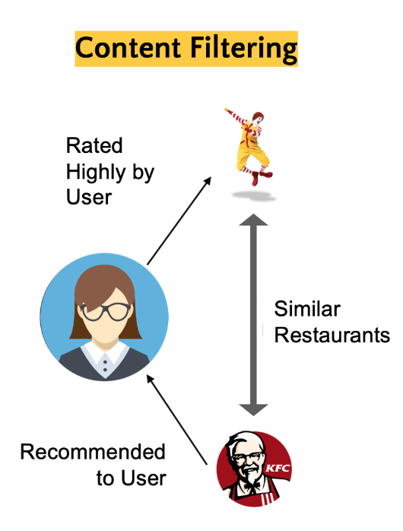

*Fig 2: Content based filtering -Image source*

Collaborative recommendation systems produce results by collecting and analyzing information based on user’s behaviors, activities or preferences. Here, users with similar likes and dislikes are clustered together. That is, if persons X and Y have the same opinion on an issue, X is likely to have similar opinions as Y on a different issue, compared to another random person. In the example illustrated below, users A and B rated Crystal Jade and Han’s highly, hence it could be assumed that users A and B have similar tastes. So, if user A rates NamNam highly, it will be recommended to user B.

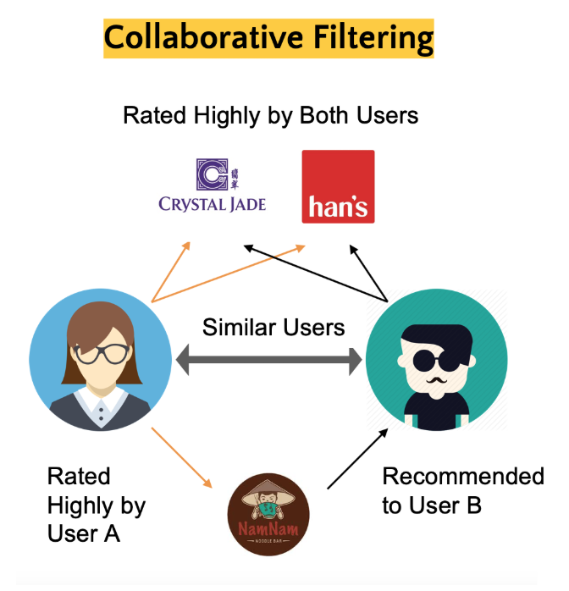

*Fig 3: Collaborative filtering - Image source* (Cheah, 2019)

A hybrid recommendation system is built by combining both content-based and collaborative recommendation systems. The benefit of a hybrid recommendation system is that they can rectify the short-comings of content-based and collaborative systems. For example, one major shortcoming of the collaborative system is that it fails when there are no ratings available for newer items/ businesses. Similarly, a content-based system does not consider what other users prefer and determining what attributes are liked or disliked by the user is not very obvious. Our hybrid recommendation system provides suggestions to users and business owners based on Yelp reviews.

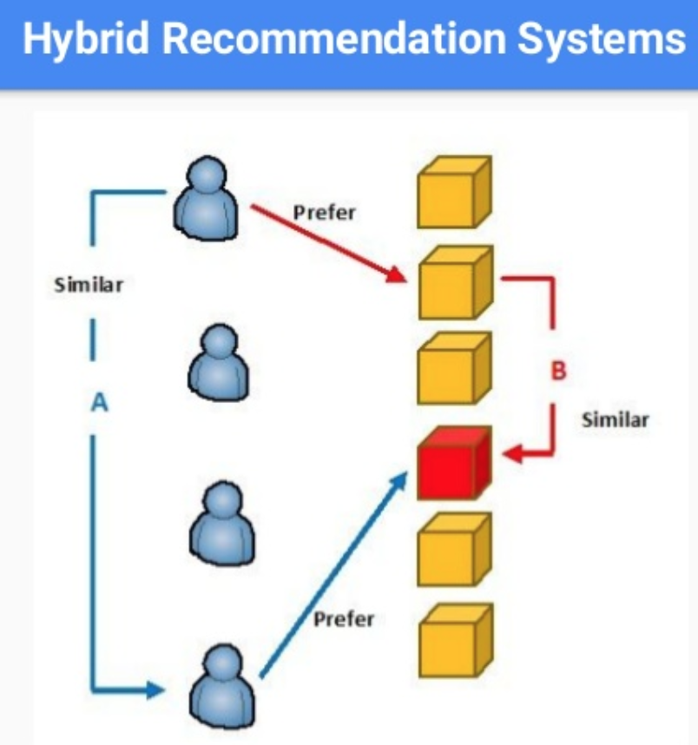

*Fig 4: Hybrid recommendation - Image source* (Nguyen, 2017)

Restaurants are categorized by the type of food and cuisines they serve. This project requires the Yelp dataset, which was extracted from Yelp.com. YelpSuggest helps new users by giving recommendations when they input keywords. It also helps businesses in identifying their areas of improvement based on the reviews they received. We have also implemented recommendations based on the user’s friends’ reviews.

# **Requirements**

In order to implement Yelp recommendations, we analyzed the existing recommendations available in the Yelp app. The distinct features we implement as a part of this project make the existing Yelp recommendation system a much-improved one, by giving personalized results separately for users and business owners. Our project requirements can be split into two: Business requirements and Customer requirements. Yelp can help in generating additional revenue by making use of its humongous data. A single Yelp user does not rate all restaurants. So, we can predict what rating a user might give to an unrated restaurant using collaborative filtering. Insights like these are helpful to identify the customers who typically like the restaurant. Yelp can also benefit from this technique, by providing the restaurants with the list of users who are likely to visit their restaurants. This can act as a revenue-generation method for both restaurants and Yelp. When the user finds that the recommendations are accurate, it helps in gaining the user’s trust for the app. This means the user will use the app more and rate more restaurants, eventually increasing the Daily Active User(DAU) (Daily Active User ) rates. Increased DAU yields higher revenue for Yelp. Thus, this is a virtuous cycle, benefiting businesses, users and Yelp itself. Customer requirements can be useful by improving the individual experience while using Yelp by giving specific personalized recommendations. For providing this, we use the customer and business datasets from the Yelp website. The end product of this project is a User Interface that can help in displaying all these results, both for the user perspective and the business perspective.

# **KDD**

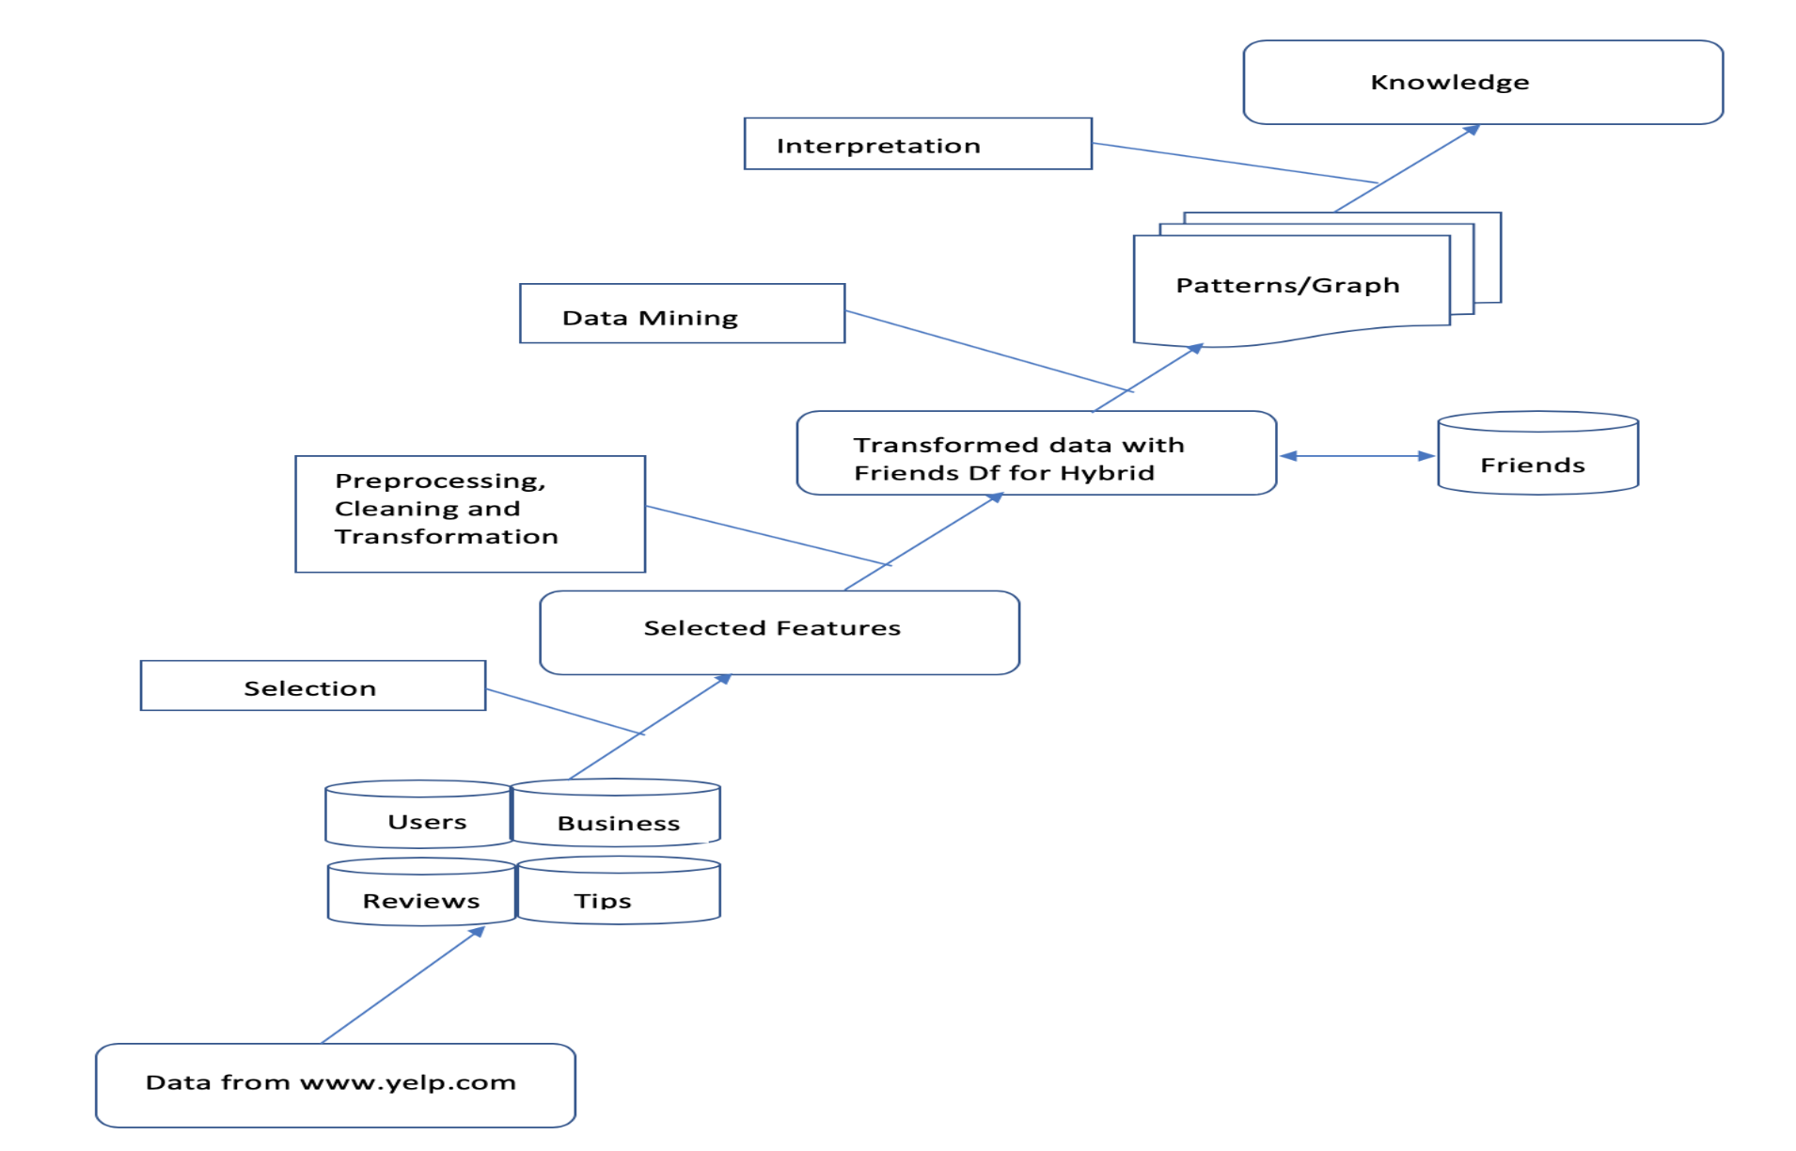

*Fig 5 : KDD process for yelp dataset*

## **Dataset Description:** This project uses the Yelp challenge 2019 dataset available at <https://www.yelp.com/dataset/challenge>. The data set contains 4,700,000 reviews on 156,000 businesses in 12 metropolitan areas 1,000,000 tips by 1,100,000 users Over 1.2 million business attributes like hours, parking, availability, and ambience. The data files are supplied in two flavours: json and SQL (MySQL, Postgres). This project utilizes the json version which has the following files:

* business.json: Contains business data including location data, attributes, and categories.
* review.json: Contains full review text data including the user_id that wrote the review and the business_id the review is written for.
* user.json: User data including the user's friend mapping and all the metadata associated with the user.
* check in.json: Check Ins on a business.
* tip.json: Tips written by a user on a business. Tips are shorter than reviews and tend to convey quick suggestions.
* photos: (from the photos auxiliary file) This file is formatted as a JSON list of objects.

As the focus of this project is on building a recommendation engine, the core files will be used are business.json, review.json, and user.json. Additionally, taking into consideration the limited hardware resources used available, data for the city of Las Vegas will be considered for building the recommendation engine.

## **Data Selection and Filtering:** We selected only business, users and reviews dataset which is needed for our analysis. Yelp dataset contains information about business with wide categories like, restaurants, hotels, travel, laundry, etc. our project is majorly concentrated on restaurants. First, we need to filter out the data, apart from ‘restaurants’ categories in all three datasets. Also, we filtered the restaurants in Las Vegas alone. Again, filtered the users and reviews datasets related to the business ids in our business dataset. After the data filtration step, we selected only the features which will be useful for our model.

## **Data Transformation:** For creating hybrid recommendation model, we need friends data. Friends data was not readily available in our dataset. We need to transform friends list in user data into friends dataset. For this transformation we have taken friends list from users dataset and one to many mapping for each users with their friends list.

|  |  |
| --- | --- |
| **User Id** | **Friends List** |
| User1 | [friends1, friends2, friends3…] |



|  |  |
| --- | --- |
| **User Id** | **Friends Id** |
| User1 | Friends1 |
| User1 | Friends2 |
| User1 | Friends3 |
| … | ….. |

*Table 1: User and friends table*

## **Pattern Evaluation and Action:** We have also performed Exploratory Data Analysis with our cleaned data. This helped us to understand more about our data. We inferred from the results that most of the users who review a business tend to give 4 and 5 ratings. One more interesting result was that from 2006 to 2018, the number of users using yelp has increased. Based on these results, we created our business rules, such as in content filtering and hybrid recommendations we chose reviews with 4 and 5 ratings for our processing.

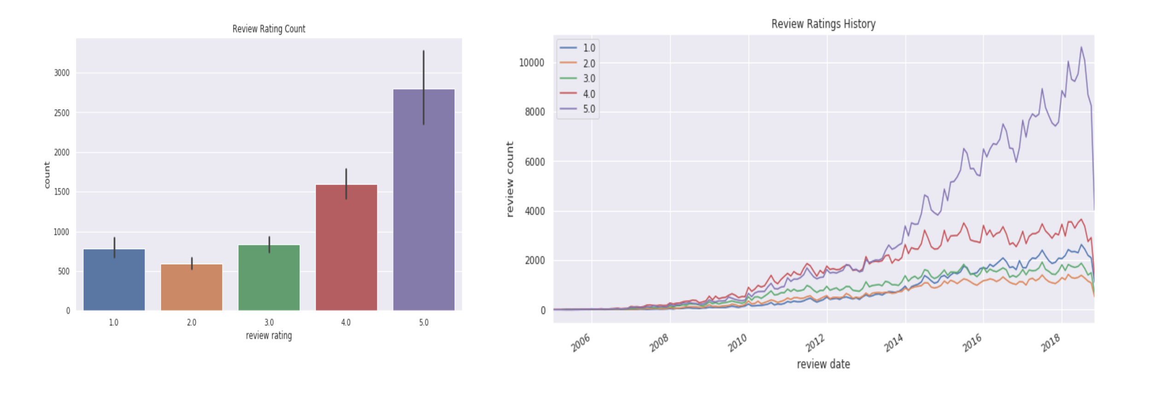

*Fig 6: Pattern evaluation of yelp data*

# **Data Pre-processing:** We used spark SQL to extract the business, users, and reviews and friends data for the city of Las Vegas from Yelp json files. We saved those files in parquet format and stored it in Amazon s3.

**Data loading summary**

* Initially we filtered the business records corresponding to Las vegas city. Total number of business in Restaurants categories in Las vegas is, **5909.** We have also select only the column which will be required for our analysis.

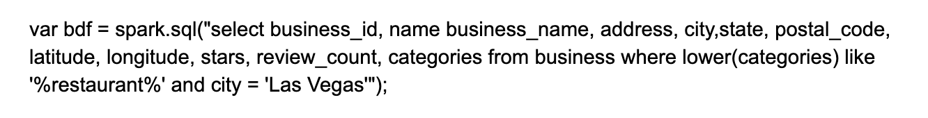

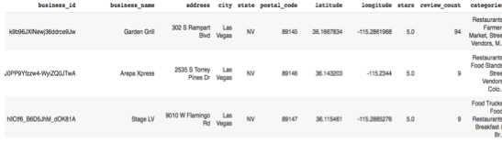

* Based on our business data, we again filtered the users data who have written reviews for our filtered businesses. Total no of users is **395843.**

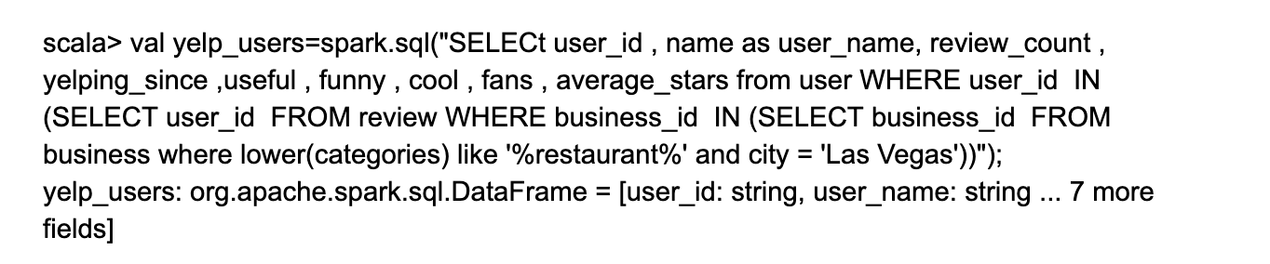

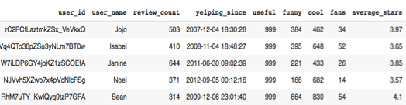

* From users data’s friend list column, we created one to many mapping for friends. The total number of Friends: **29166583.** We were not able to handle this huge data as single parquet file. Hence, we stored friends data partitioned into 2 parquet files.

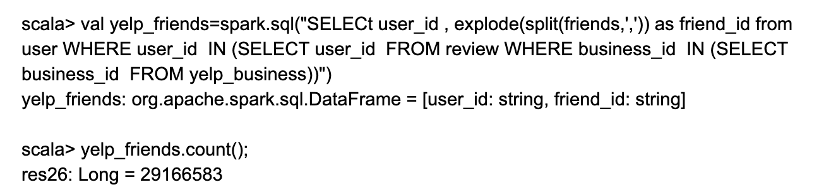

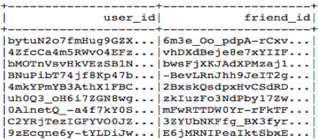

* We need only the reviews corresponding to our filtered businesses. Total number of reviews after filtering is, **1076129.**

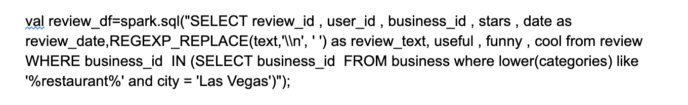

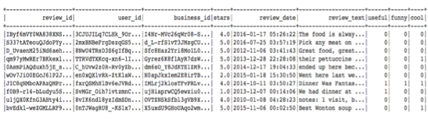

## **Review Rating Analysis :** We analyzed the data using Pyspark in Google collab and data bricks. As we can observe from the below graphs the number of ratings for 4 and 5 stars increased are very high compared to 1,2 and 3 ratings. And also numbers of ratings given by the users are increased over time.

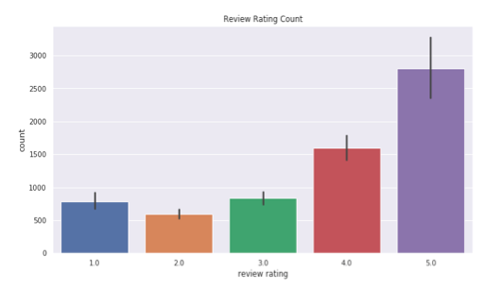

*Fig 7: Review rating count*

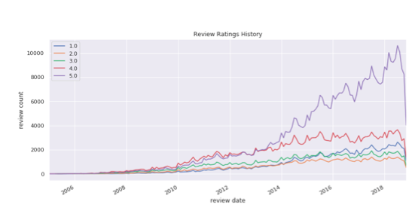

*Fig 8: Review rating history*

# **Feature Engineering**

It’s been said that Data is like a crude oil for the Machine learning models, which implies it has to be refined into features to train any models (Koehrsen, 2018). In order to train an accurate model, we need to extract relevant features from the data, which is known as Feature Engineering. Feature Engineering comes under Data Preprocessing stage in Machine Learning pipeline. According to the survey based in forbes, Data Scientists spend 80% of the time in Data Preprocessing phase (Rencberoglu, 2019). For our Yelp Dataset we applied below techniques in this process.

* **Grouping operations**: We used group by operations in our dataset to get the reviews that belongs to a particular business and also to get the reviews that was given by a specific user. These results are used in content based filtering technique.

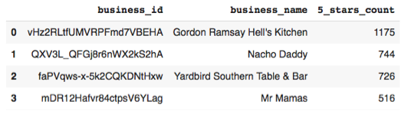

* **TF-IDF Modeling:** TF-IDF technique was introduced for feature selection. This method is similar to Bag of words instead it uses TF-IDF values for each word rather than considering frequency counts. In order to limit the number of words that are common in both positive and negative reviews, this method ignores the frequency of words with more than 50 as they will not contribute much to the classifier (Goyal). In content based filtering technique, the recommendation engine depends mainly on the item attributes and the similarities between them. In order to get those attributes we aggregated the review text for each restaurant and applied TF-IDF technique

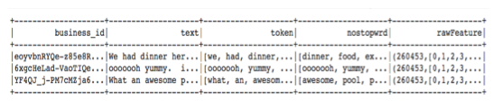

.

* **Word2Vec**: Word2vec is the new way of representing words as vectors. The main idea behind word embedding is to redefine the high dimensional word features into low dimensional feature by maintaining the contextual similarity words in the corpus. One important aspect of Word2vec is that it doesn’t require any labeled data. The main advantages of Word2vec method is, it helps in reducing the number of features for building the model. And also it detects the meanings of the words, semantic relationships and the different types of contexts they are used in. These word vectors are positioned in the vector space such that words that share common contexts in the corpus are located in close proximity to one another in the space (Gupta, 2019). Similarly as described above we applied word2vec technique to the item attributes.

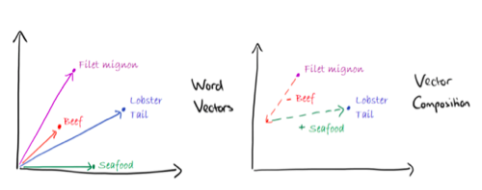

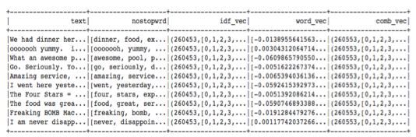

* **Topic Modeling**

Generally, topics were defined as repeating group of words, which are statistically significant to corpus. Here the statistical Significance reference to a group of words occurring together and also having the similar range of Term Frequency - Identity frequency values as well. LDA(Latent Dirichlet Allocation) is the hidden idea behind the unsupervised approach in building the topic modeling in our case. This method basically generates and maximizes the probability of a word belongs to a certain topic. In LDA topics were fixed, and it is one of the tuning parameters as well. We start of by setting up initial number of topics that are to be generated from the given document using LDA. The top N words with a high probability score in their range, shows the word belongingness to certain topic (Bansal, 2016). Following were the words with probability score weightage, that shows words belongingness to topic 1.

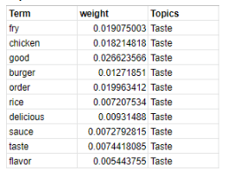

# 

# **High Level Architecture Design**

# 

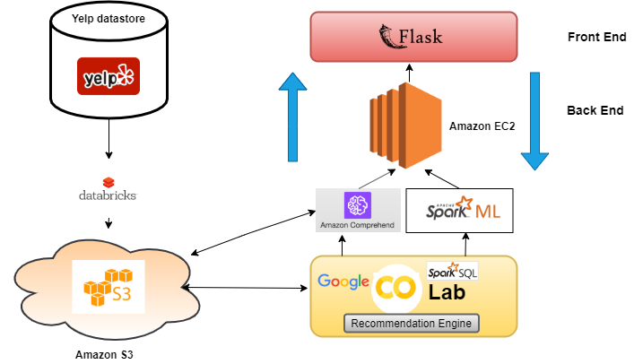

*Fig 9: Backend and Frontend Platform Architecture*

The data for this project was retrieved from yelp data store. There are lots of unnecessary columns present in the dataset. It is important for any data science project to filter the redundant features based on the business objectives.

Actual size of the data was 5 GB, which was later filtered with databricks. The filtered data was reached to 2GB size. Once the filtered data is ready, it is loaded into Amazon S3. Amazon S3 was our base data storage for our project. Necessary preprocessing were done using Google Colab and PysparkSql.

There are two faces for our project. One is for customer and the other is business. For helping the customers insearch of restaurants of their interest and / or through their friends network we used SparkML in building the Machine Learning models. For business end, we chose Amazon Comprehend which is a Natural Language Processing based AutoML. It generates necessary topics that helps business through topic modeling. Once the necessary topics were generated, and based on the average rating score the topics were shown as necessary recommendations for the business people.

The entire model was deployed and hosted on Amazon EC2 and front end was designed using flask. It provides the interface for both customers and business.

**Description on Tools and Technologies implemented in the project:**

**Databricks**: The databricks is a just in time data platform which is built on top of Apache Spark. Initially it is started by connecting through the existing storage with orchestrated spark clusters and databricks manage service in the cloud

**AWS S3:**Amazon Web Service Simple Storage Service, provides cloud storage which is built for storing and recovering any amount data anywhere in the world using the internet. In our project, once the data was filtered the required data was stored at S3

**Google Colab**: It is a kind of Jupyter notebook, which is powered by Google. It runs on cloud premises supports both GPU and TPU processings.

**Apache spark**: It is a big data processing tool built on top of Hadoop and Map-Reduce .The one unique feature that distinguishes spark with other tools were, Spark is having in memory cluster computing which increases speed of processing. Spark supports three languages Scala, Python and R. For our project we used Pyspark, SparkSql was used in part of feature engineering and Spark ML was used in building the model.

**Amazon Comprehend**: Amazon Comprehend or AWS comprehend is one of the NLP (Natural Language Processing) and machine learning powered services that helps in finding the insights and relations in the text data.

This Amazon AutoML helps uniquely in identifying the relations from the text (Amazon Comprehend)**.**

Following were some of the key tasks that can be performed by this Amazon’s AutoML

* Keyphrase Extraction
* Sentiment Analysis
* Entity Recognition
* Language Detection
* Topic Modelling

In this project while designing the backend architecture for the business users, we implemented Amazon’s AutoML i.e Amazon Comprehend in detecting the topics from the reviews given by the customers on their business. After tuning the topics we stick to top five topics that are most frequently appeared in the reviews.

**Amazon EC2:** Amazon Elastic Compute Cloud or EC2 helps in obtaining Virtual servers or compute cloud instances in the cloud. EC2 instances can be structured, scaled up/down according to our requirements. Instances are located geographically at different locations and connected with having a low latency networks (Ec2)**.**

**Flask:** Flask is an web-app based python framework which consists of modules and libraries for developers without bothering about other smaller levels such as protocols, thread management**.** For both businesses and customers we used flask in developing the interface.

From the generated topics, we created five cards which displays recommendation for the business users based on customers feedback. Each card is subjected to change in color to either green or red based on some threshold value. Once the topic were detected we performed the aggregate average rating for each topic for each business user. Change in average rating value for a topic changes the color.

The green color signifies the restaurant is doing good based on the customers review, whereas, red signifies they were bad or business should look into that area.

# **Data flow diagram**

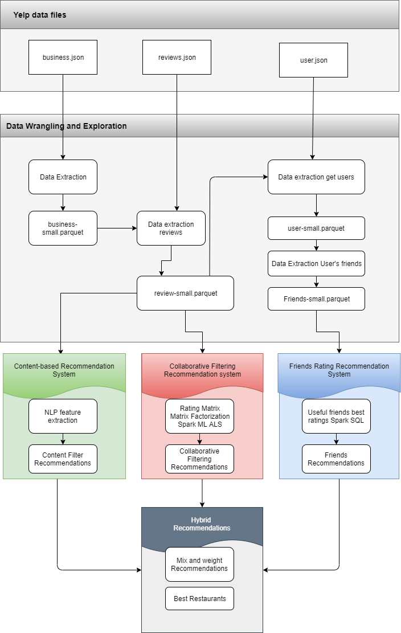

*Fig 10: Data flow chart for customer recommendation system*

The necessary datasets for building the customer end recommendations were business, reviews and users data. The data for building the models were extracted from these sources. The sourced data was converted into parquet file and model development was done on top of it Three recommendation systems were designed in this project they are Content based, Collaborative, and friends rating recommendations. Looking over the bottlenecks and drawbacks of these systems, we designed anHybrid recommendation system.

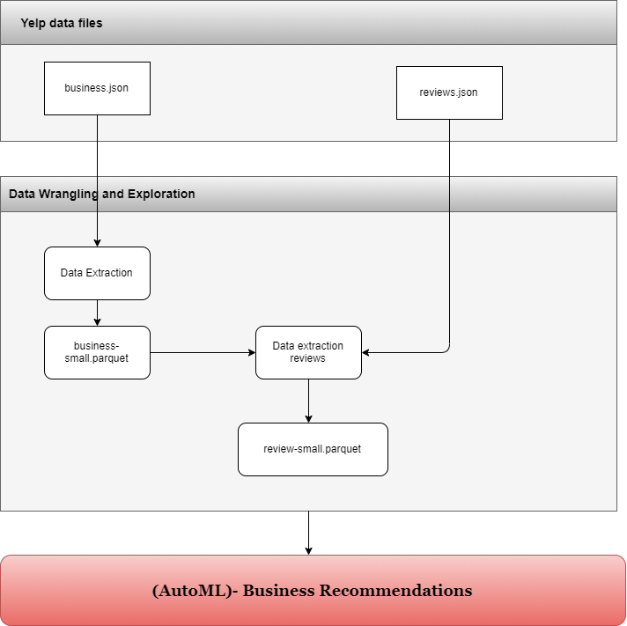

*Fig 11: Data flow chart for business Recommendation system*

For business end we chosen business and reviews given by the customers. The necessary data was converted to parquet and pushed into Amazon S3. Through an API from amazon s3 we connected it to Amazon Comprehend for generating Topics from the review data.

In this project we extracted the Las Vegas restaurants category data for our purpose. We extracted nearly 5909 restaurants, in which, we took 2680 restaurants based on top user review count.

# **Workflow:**

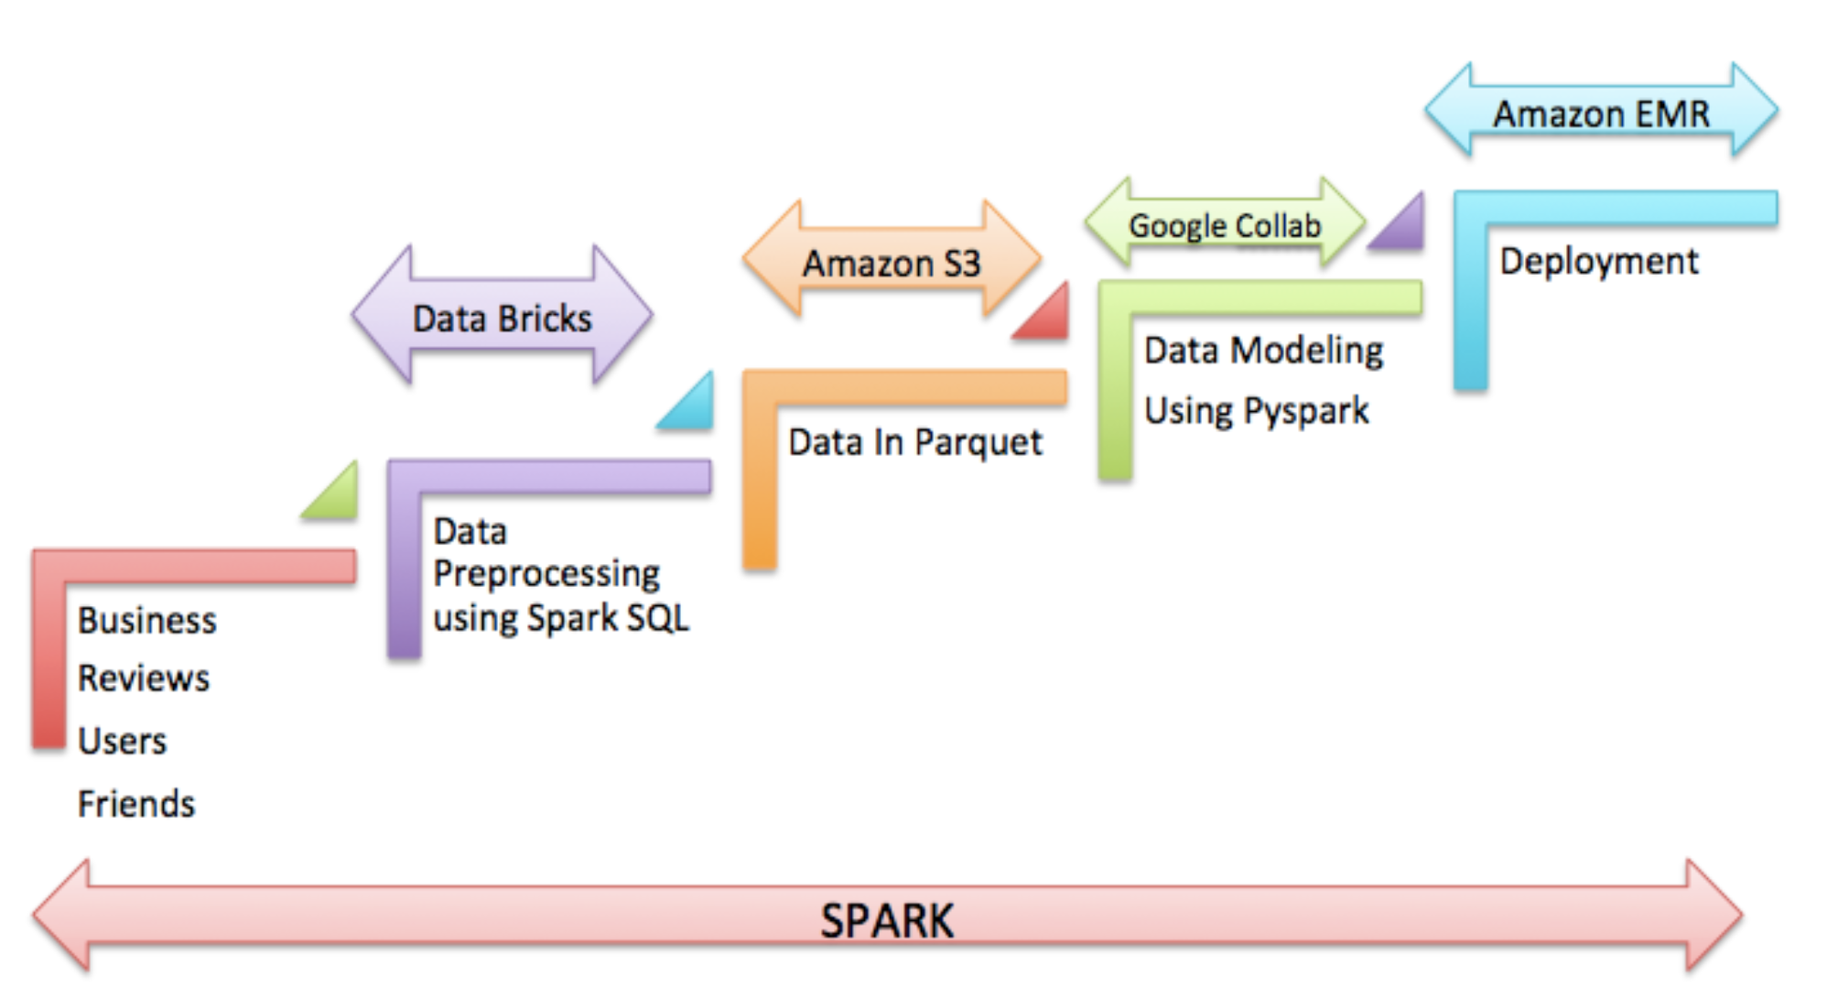

*Fig 12: Datawork flow using various tools*

For this project, we are handling with huge data which was not possible to be handled in our local machines. Hence, we decided to explore all available cloud platforms and choose one which will be suitable for our requirements. We were not able to find one single platform for all our needs with respect to our cost constraints. At most we used free cloud resources wherever possible. This above diagram clearly picturizes our data flow from data source to model deployment. For data preprocessing, we tried installing spark locally and using other resources online. Databricks provided us 6GB spark cluster. We were able to do all our data preprocessing using spark sql and manually uploaded our processed parquet files to S3, for centralized data storage. Parquet is an open source file format available in Hadoop. Parquet stores data with nested data structures in column orientation which make more storage efficient (Parquet). We were able to reduce 3GB of our clean data to ~2GB by using parquet format. Also, S3 storage is free for students with AWS account. Later for building our models, we need a platform which can run spark. Our available Databricks cluster has only one node and it was not to run our machine learning model code. After analysis, we used Google colab for EDA and to build our models. Colab by default had support for pyspark which made us easier to run our spark codes. After building our model, we wanted to deploy it any cloud services. Initially we tried, EC2 cluster with T1 instance type which was freely available, but this cluster was not large enough to run our machine learning codes. Later we created Amazon EMR cluster with i3.xlarge which costed us 30 USD for our entire work. We were able to load our deployed model from EMR and displayed the results using Flask server and HTML pages.

# **Data Science Algorithms & Features Used**

## **Content Based Recommendation System:** Content based filtering makes use of item features and recommends similar items to the user based on their previous actions (Content-based Filtering). In particular various items are compared with the items previously rated by the user and the best similar items are recommended. Here in this model a user profile is built based on the weighted vectors of item features. These weights represent the significance of each feature to the user and calculated using individually rated content vectors obtained from various algorithms like cluster analysis and decision trees in order to find the estimate probability of user likes an item.

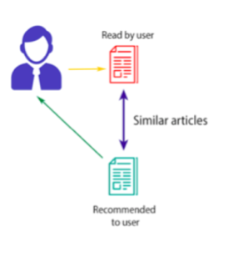

*Fig 13: High-level conceptual idea on recommendation engine functionality*

In this project we built user’s profile based on the ratings given by the user in the past where the star ratings of the restaurants are greater than 3. This dynamic set consisting of users profile is then compared with existing Restaurants to get a best similar restaurant that was not seen by the user before.

**Cosine Similarity:** In addition to the word vectors we can get the similarity of the two documents based on the cosine similarity. This is obtained by the dot product of the two vectors by the product of the magnitude of those two vectors. At last it gives the angle between the two vectors. Lower the angle means the documents are similar to each other. Higher the angle means the documents are dissimilar.

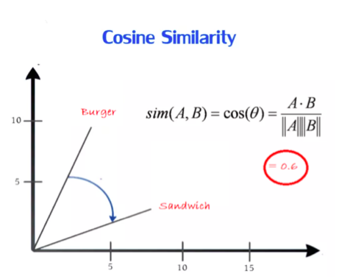

*Fig 14: Cosine Similarity*

**Pros content based filtering technique**

* **User Independence**: This model doesn’t need any details about other users, since the recommendations are based only to specific user. This helps in scaling up large number of users.
* **No cold start**: New items can be recommended before being rated by a considerable number of users.

**Cons of content based filtering**

* The model can recommend based on the existing interests of the user. It has limited capability to expand.

**Content based Filtering results:** Here the features used for content based filtering are business id, reviews, user id, business categories and star ratings. After Feature extraction in the text-preprocessing pipeline the user profile from restaurants is built based on the ratings given by the user in the past. And then later the recommendations were generated based on the cosine similarity between the user and reviews score.

**Text processing pipeline :** For content based filtering we used the reviews text given by the user. Before converting the words into vectors, some natural language processing techniques need to be applied to transform the raw text into resultant features. These steps include tokenization, stopwords removal, feature engineering and cosine similarity.

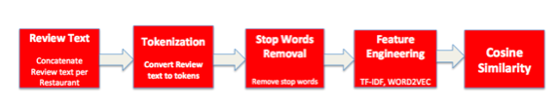

*Fig 15: Text Pre-processing*

**User Profile:**  Business previously reviewed by the user: ‘3nDUQBjKyVor5wV0reJChg’

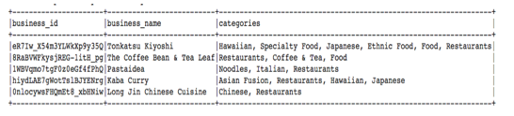

**Recommendations based on content based filtering**

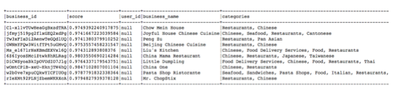

**Key word Search:** This method is implemented to combat the cold –start problem in content based filtering approach i.e., an issue that happens when the new user has no past ratings in the database. In order to resolve this NLP based keyword search is implemented rather than the user profile. So, typing “Chicken Cheese Burger” into our app will result in recommending restaurants similar to American restaurants similar to Burgers and Sandwiches.

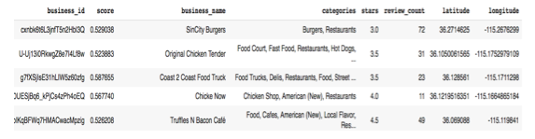

## **Collaborative Filtering :** Collaborative filtering aims at predicting the user interests by collecting the preferences or taste information from many users. This method fills the missing entries of user–item ratings association matrix. The underlying assumption of the collaborative filtering approach is that if a person A has the same opinion as a person B on an issue, A is more likely to have B's opinion on a different issue than that of a randomly chosen person. This differs from content based filtering is that the item itself doesn’t play a role in recommendation. The good thing it handles the sparse matrix.

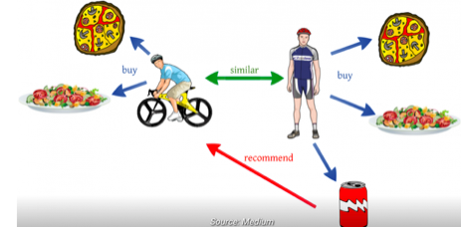

*Fig 16: Intuitive illustration on Collaborative technique*

**Matrix Factorization :** The main input parameters to the collaborative filtering are userid, business_id and ratings. Matrix factorization helps in identifying the latent features that helps in finding the patterns that the users rated the Restaurants. This method decomposes matrix into two lower dimensional matrix i.e. user matrix and Business matrix in such a way that the product of these two gives the original matrix.

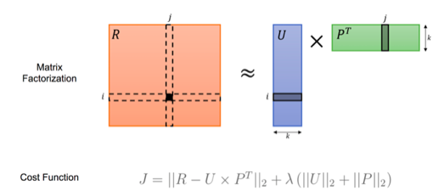

*Fig 17: Matrix Factorization*

The first term in the cost function represents the difference between the original matrix and approximation matrix U x PT. The second term is the regularization parameter used to avoid over fitting. Alternating Least Square algorithm (ALS) is a two-step iterative optimization process. In every iteration it first fixes for P and solves for U. And in the next iteration it fixes U and solves for U. Since Ordinary least square (OLS) approach is a Unique technique and guarantees a minimum MSE. In each step the cost function decreases or remains unchanged. This kind of alternating helps in reducing the cost function until converges.

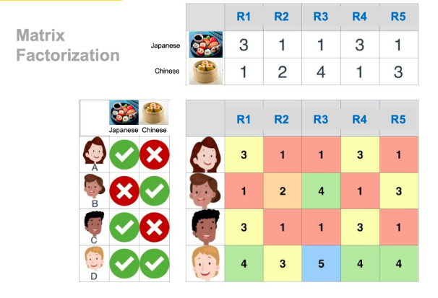

*Fig 18: Matrix factorization of yelp data*

Apache Spark ML library has ALS technique and thus it’s been used in collaborative filtering. We trained the model using the rating matrix and able to achieve mean squared error of 1.58 using cross validation and hyper parameter tuning techniques.

**Collaborative Filtering Results:** For the rating matrix the number of rows are **395843**

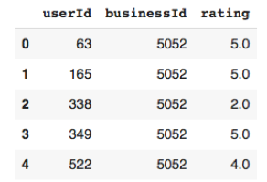

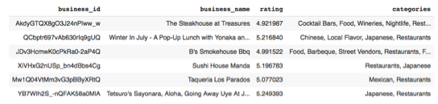

## **Friends Recommendation:** In this we filtered the top restaurants that were rated by user’s friends (4 or 5). The underlying assumption is that users trust the suggestions that his friends have given. Only the first layer of users friends network was considered.

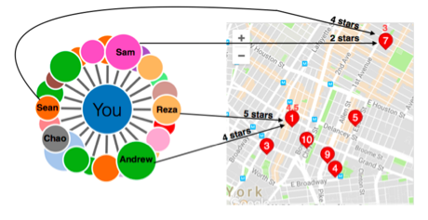

*Fig 19: Friends recommendation*

**Friends Recommendation result**s:

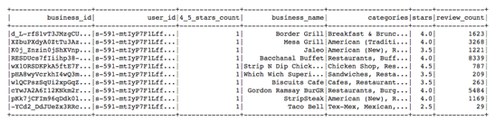

## **Hybrid Recommendation:** Burke 2002 explained different strategies to implement Hybrid recommendation. He classified them into seven categories.

* **Weighted**: The score different recommendations are combined numerically.
* **Switching**: The system chooses among recommendations components and applies the selected one.
* **Mixed**: Recommendations from different recommenders are presented together.
* **Feature Combinations**: Features derived from different knowledge sources are combined together and given to a single recommendation algorithm.
* **Feature Augmentation**: One recommendation technique is used to compute a feature or set of features, which is then part of the next input technique.
* **Cascade**: Recommendations are given strict priority, with the lower priority ones breaking ties in the scoring of the higher ones.
* **Meta-level**: One recommendation is applied and produces some sort of model, which is then the input to the next technique.

In this project we implemented the mixed hybrid strategy. All the recommendation types that have been mentioned earlier were included in a single recommendation engine.

* Content-based filtering recommendations
* Keywords search recommendations
* Collaborative filtering recommendations
* Friends Network recommendations
* Hybrid recommendations

**Hybrid Recommendation results**

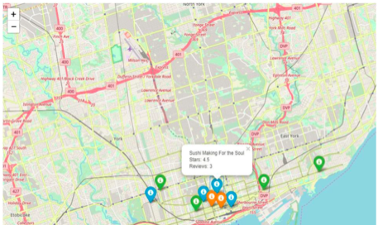

*Fig 20: Hybrid recommendation map*

# **Testing**

## **K-FOLD cross validation technique:** Determining the right train/test split ratio is a never-ending problem in data science projects. The optimal tradeoff between the train and the test set has to be determined. The train test split ratio mainly depends on two things, the total number of samples in your data and the machine learning model itself (Shah, 2017). Different machine learning models need different sizes of train and test datasets. In general, the test data should meet the following characteristics:

1. It should be large enough to yield statistically meaningful insights for all scenarios.
2. It should be a part of the whole dataset, and it should not have different characteristics from the training dataset.

Based on these criteria, we assume that it will be easier to determine when we design and train various models. This implies that there will be an iterative process involved in determining the train test split size.

Evaluating the Machine Learning model is quite a difficult task. Normally, we split the data into training and testing sets and use these sets for training and testing the Machine Learning models. And then we validate the model performance based on evaluation metrics (Krishni, 2018). This kind of implementation is not reliable, as the accuracy obtained from one data set is totally different from the accuracy obtained from other test data. In that case, K-fold cross-validation combats the problem by dividing the data into folds and make sure that each fold is used as a test set. Then the average of all folds is taken to calculate the accuracy of the model (Krishni, 2018)

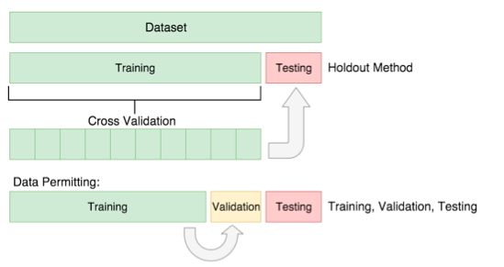

*Fig 21: K-Fold cross validation*

**Interfaces -- UI, Business, User, Login Page**

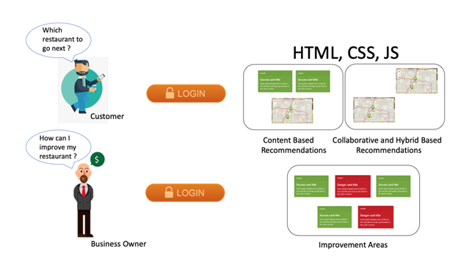

*Fig 22: Frontend design for customer and Business owner*

Since our flask application has 2 separate components, one for the business users and other for the normal users(customers). It is implied that both these components will have separate Web UI pages. As customer who logins to the application, will want to know which restaurant he should go next, whereas if a business owner logs in, he will want to know how he can improve his restaurant further. The web UI page for the business user is quite intuitive in the sense of showing few topic cards in red and green color representing areas of improvement and areas doing well respectively. The web UI pages for the normal users(customers) has three sub pages (one each for Content, Collaborative and Hybrid Recommendations ) that can be navigated from one another and each of these pages are composed of a map to pinpoint the recommendations locations, a keyword search textbox to display the recommendations for the user given keyword and ordered list of recommendations of restaurants.

UI Screenshots of our Yelp Suggest Application:

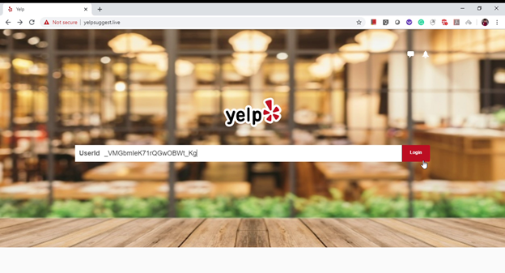

*Fig 23: Login Page*

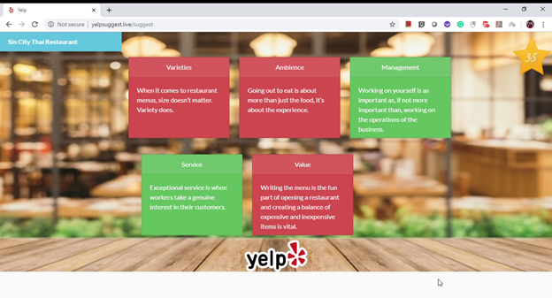

*Fig 24: Business Owner View*

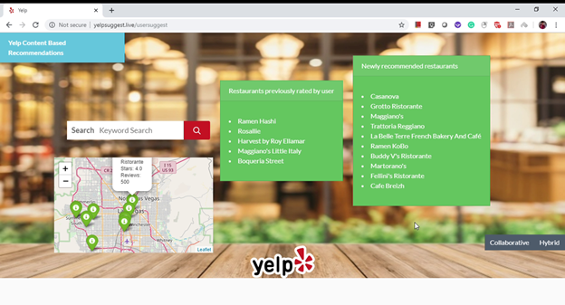

*Fig 25: Customer View*

**Client – Side Technologies Used:** HTML – It is a markup language that is understood by the web. Local web browsers can decode this language to display the contents on to the GUI. Since markup languages are also semi structured format, they can be transported in an HTTP requests and responses.

**CSS** : Cascading Styling Sheet, as the name implies it is used to stylize the HTML elements and this stylization can be cascaded to the subsequent elements within a div class.

**JavaScript** : It is a client-side scripting language, predominantly used for client-side validation of the user inputs. However, it can also be used to conditionally display the stylized HTML elements onto the web browser.

**Bootstrap Framework** : It is a pre-defined CSS sheet, which includes all the styles for each and every HTML element. It can easily be included in an HTML page and can be overwritten with inline styling within HTML tags.

# **RESTFul & Server Side Design**

# 

*Fig 26: Restful and server Design*

**RESTFul Services:** For storage we have used Amazon S3. In order to download from S3 and upload to S3, we have used the Boto3 client which is RESTFul API service published by Amazon to interact with their cloud products. In order to use Boto3 Client, first it needs to be authenticated with credentials such as “Access Key” and “Secret Access Key” (SDK for python).

**Server-Side Design:** From the Web UI, whenever a user submits an HTML form, in our case, the user submits his User Id / Business Id and this user input is bundled as an http request and sent to NGINX web server hosted at a distant location. The WSGI http server Gunicorn translates the request into a format interpretable by our python code for execution. The Flask is a light-weight web application framework for python. The given user input is checked to redirect to appropriate Web UI pages (Business/Customer) and subsequent code in spark is executed in Amazon EMR clusters. There is no need for configuring spark as the entire flask application along with all the static, CSS and HTML file are hosted in EMR cluster(which is Amazon’s take on doing Spark in-memory computations) (Gunicorn and Nginx in a Nutshell).

**Client-side Design:** The end product of our project is the User Interface(UI) named *YelpSuggest.live*. The client-side design is a very simple, user-friendly UI, where one can enter Business ID or UserID to get recommendations. The initial screen is displayed below

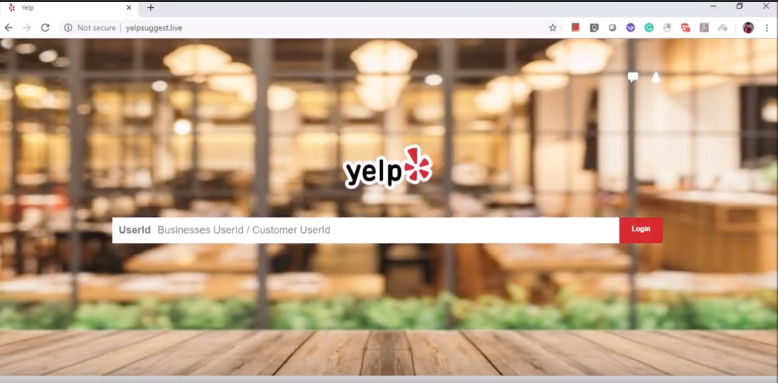

*Fig 27: Client side design*

Once the business owner enters the respective ID, the user receives a resultant matrix of cards, in colors green and red. The green cards denote the areas where the restaurant is already doing well. The red cards mean that the displayed areas need improvement. The stars are also displayed in the top right corner of the UI. For example, in the below example, the restaurant needs to improve its ambiance, varieties, and values. It is seen to be already doing great on management and service. The overall rating 3.5 is displayed at the rightmost top corner.

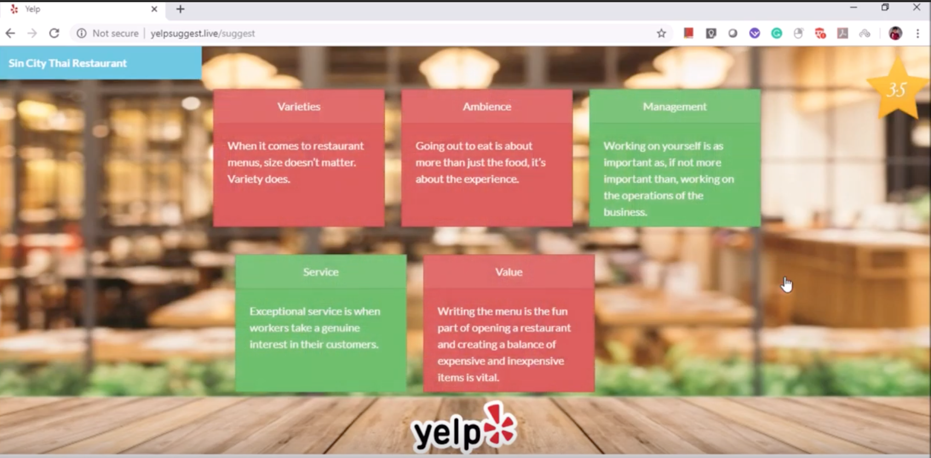

*Fig 28: Recommendations based on customer review for businesses using Topic modeling*

There are different tabs for Content-based, collaborative and hybrid recommendations. In the content-based tab, it is seen that the results are the restaurants previously rated by the user and the newly recommended restaurants. There is also a map display, with pins denting the recommended results.

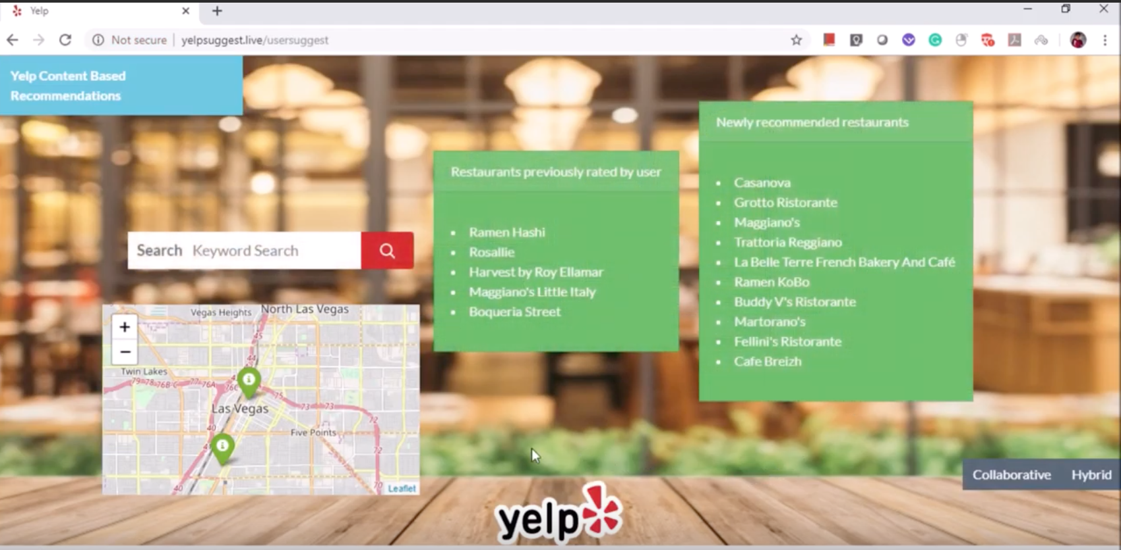

*Fig 29: Customer recommendations based on hybrid model*

The pins on the map also provide details when the cursor hovers over it.

# **Model Deployment**

Model deployment is the final stage of machine learning life cycle. It is the process of serializing the model instance and hosting it on a high end node. In order to serialize an object, we save the instance in pkl format and load the file by importing the pickle package. Below is the implementationof saving and load a pickle file (Machine Learning model).

# Save

saved_model = pickle.dumps(model)

# Load

model= pickle.loads(saved_model)

# predictions

model.predict(X_test)

Typically, the model would be saved in a cloud storage and deployed on to a high-end node with endpoint configured. The flask application should be able to send input API requests to the endpoints and display the output onto the UI.

**User perspective:** In our case, each user has unique data points and the recommendation model, pipelined for one user will be different from others, therefore each user needs to have a separate model in place and the model should be retrained after a certain period with new comments data for every user.

**Business Owner perspective:** We use cloud Auto ML solution i.e. Amazon Comprehend for topic modelling of restaurant reviews (1M reviews limit). Amazon comprehend internally uses LDA Topic modelling (Topic Modeling) and we should submit Amazon comprehend jobs for all the reviews in each region and work on corresponding outputs, Region wise. (Deploy Region wise Topic modelling Jobs in Amazon Comprehend). And here also the model should be retrained after a certain period with new comments data for every region.

# **HPC**

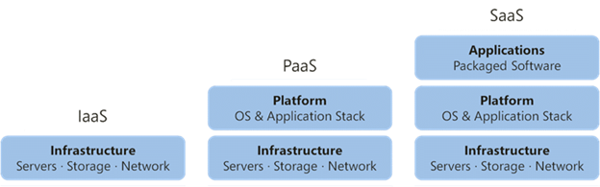

*Fig 30: HPC tools*

High performance computing can be achieved with the pay as you go model usage of cloud resources as opposed to buying costly physical machines with high end configurations. Every cloud service provider has products for various stacks of cloud service models.

**IAAS** : In this, the infrastructure is commoditized. That means any application built on this stack should have a platform built that can enable more low level customization.

**PAAS:** In this, the infrastructure and platform are readily available to choose, and the application is deployed on such platforms. It is a quick process with very little underlying configurations.

**SAAS:** In this, along with the infrastructure, platform, the entire application is packaged for use . Need not worry about the storage and computation power. Everything scaled and self-managed.

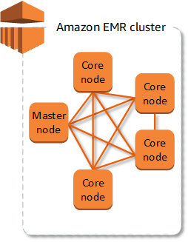

*Fig 31-EMR cluster-* (Management guide)

For our project we have used PAAS cloud service model provided by Amazon. i.e Amazon EMR cluster. Which are cluster of virtual machine instances with spark installed, internal schedulers are in place for automatic resource management and has HDFS as default file system for storage.

A cluster is a collection of machines and each cluster is composed of 3 kinds of machine types:

* **Master node**: A node that manages the cluster by distributing the tasks and monitors the health of the cluster.
* **Core node:** A node which has all the core software components to run tasks and store data in HDFS
* **Task node:**  A node which has all the core software components to run tasks and do not store data in HDFS. These types of nodes are optional.

**MVC Design Patterns**

Model-View-Controller design pattern is recently widely used all web applications. In our project, we have used Flask server for our web application. Flask uses minimal version of MVC patterns. MVC patterns was mainly used decouple the business logic from web pages. Here, user requests are completely handled by controller, controller in turn interacts with models (DB layer) to retrieve the data and return the result to views (HTML pages). Controller has full control over data and views. Typically, a flask app looks like below structure (Flask-Framework)

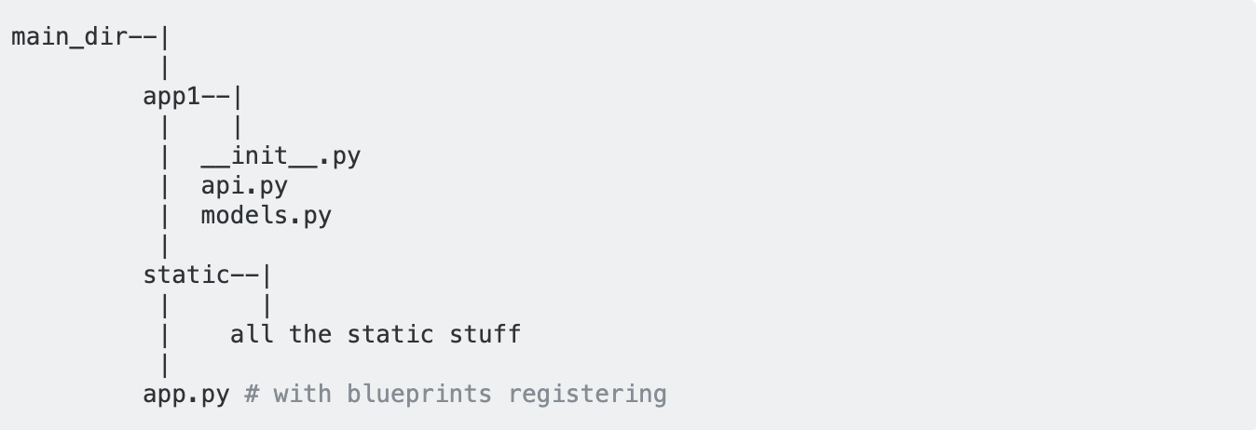

App.py acts as controller and bridges the gap between model and view (static templates). In our project AWS S3 is our DB layer and HTML pages with iframe is our views. App.py receives all user requests and performs all business logics by interacting with DB layer. The resultant data is returned from app.py to HTML pages. Hence, our project clearly follows MVC design patterns.

For building collaborative filtering in ALS method we implemented the 5-fold cross validation techniques.

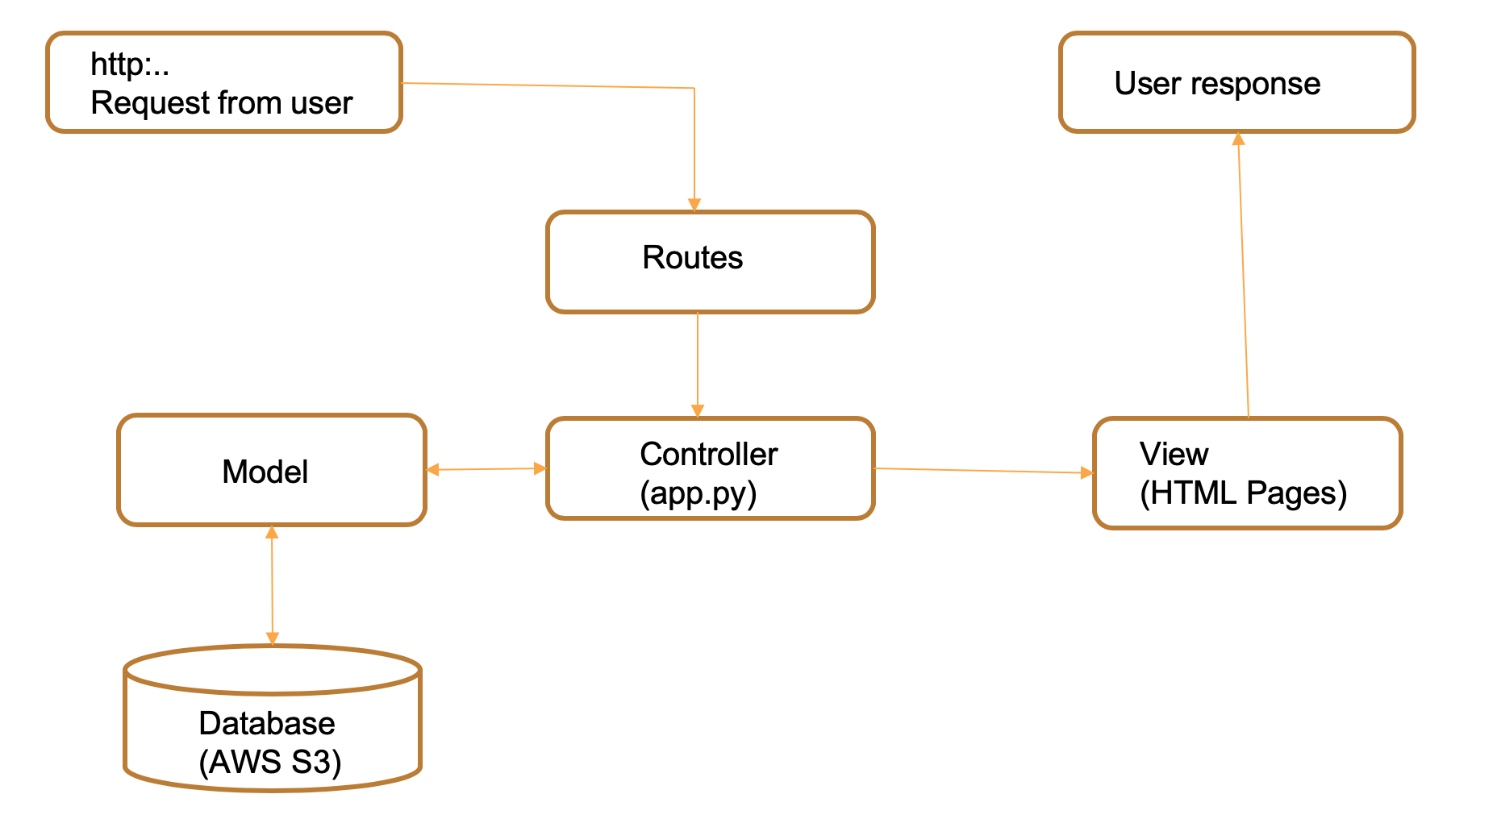

*Fig 33 : MVC design patterns*

**AutoML or Serverless AI**

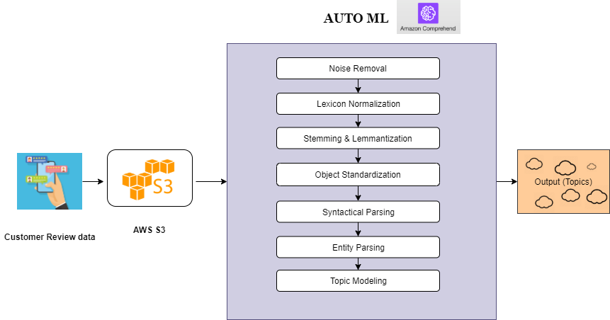

*Fig 34: AutoML work flow chart*

This is an AutoML tool which takes care of end-to-end processing of text data and produces results.Here the results were topics generated from the reviews data. This tool identifies entities,key phrases, sentiment etc. In our project we used it in detecting the topics from the customer reviews on restaurants.

Once the topics were generated by the AWS comprehend with the probability scores. The data is analysed both by machines and humans. The topic modeling was done in such a way that actions can be taken immediately by the business to help in generating more revenues based on the customers feedback on their business.

The above shown image was typical workflow of the AutoML which is incorporated in this project. The processed customer review data is stored in AWS S3, from there through an API we connected it to the AWS AutoML for NLP services.

Prior to pushing the data into Amazon Comprehend, it is important to specify how many topics we want to generate from the data. Initially we tuned the topics ranging from 5-9 and finally stick with five which provided maximum context from our data.

Following is the image showing the job status using AWS comprehend for the business data.

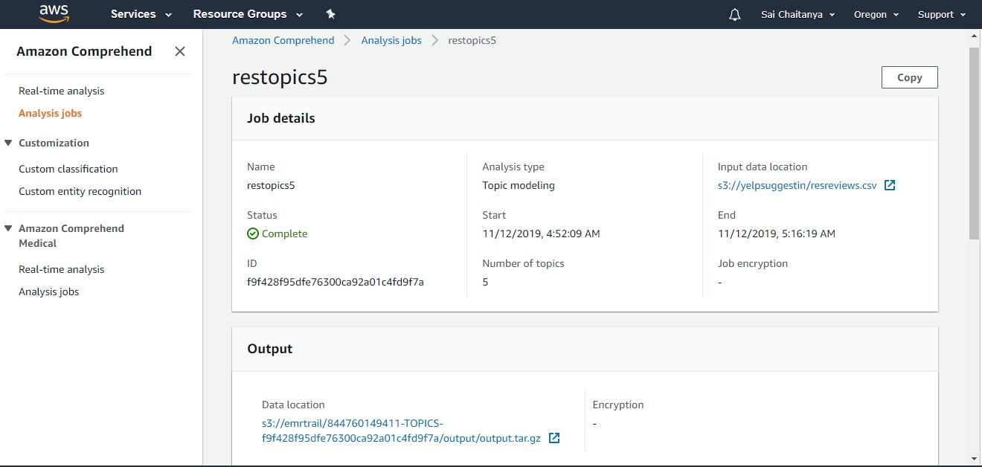

*Fig 35: File output status in AWS comprehend.*

The job took nearly 24 minutes to process and output the result. Input data was retrieved from S3 and the output was stored again in AWS S3 itself.

# 

# **Data Engineering**

Data scientists spend 80% of their time data cleaning and preparation (Armand Ruiz, 2017). We realized that building an efficient data pipeline including all data preprocessing steps will help us to rerun our preprocessing steps and to transform the latest data whenever needed. Our data pipeline is simple, but it involves complex data selection and transformation logic. We created two important data pipelines for our models.

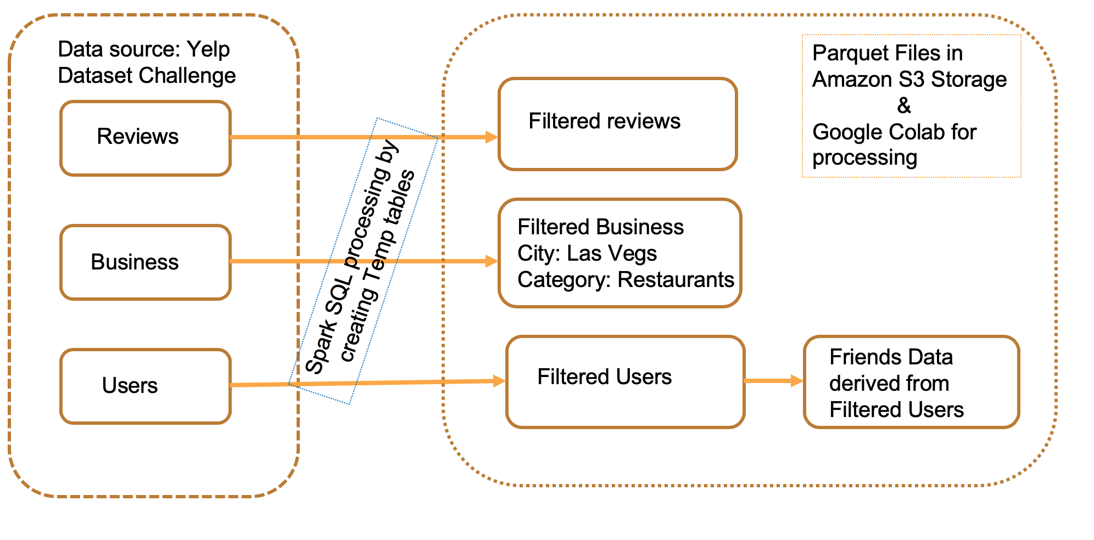

*Fig 36: Data processing flow using Apache Spark*

Above diagram shows general data pipeline used to transform our raw data to our centralized storage which can be consumed directly by our models. All our data preprocessing steps are explained in previous sections.

We have built content and collaborative model with review text as input and we have also used Amazon comprehend which directly used our review text without any further processing. For some of the models, further processing of our review text was required. Hence, we developed another data pipeline which converts our review text into IDF vector and word2vec.

*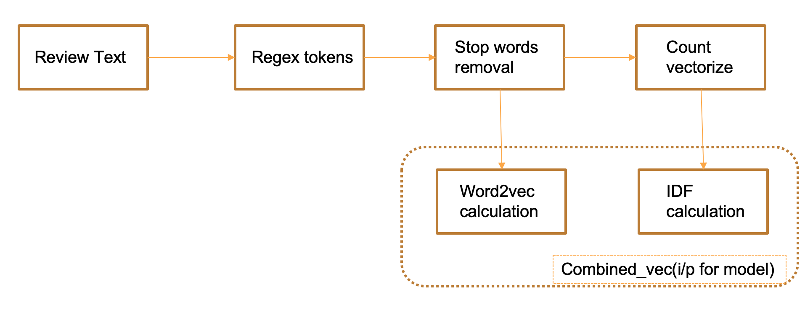 Fig 37: Text processing pipeline*

This data pipeline takes review text as input, in further steps tokenizes the text, removes all stop words, calculates word2vec and IDF vectors (based on count vectors). Final features, word2vec and IDF vectors are combined to form combined_vec, which is served as input for our models.

Below are data engineering tools explored and used in our project,

**Spark:** Apache Spark is used all over in our project to perform preprocessing and data analytics. The data downloaded from yelp is pre-processed using Spark framework. For efficient recommendations, this huge input data has to be processed, which can be achieved using Spark. Spark works more efficiently than the MapReduce model, and it supports some features that MapReduce does not support such as interactive queries, stream processing and in-memory computing. It offers API’s in Python, Java, Scala, SQL, Spark ML and Spark SQL. It is used to combine and integrate with some big data tools to perform stream processing and analytics. We have used spark in Databricks, Colab and Amazon EMR platforms in this project.

**Spark SQL:** Spark SQL is a spark module for structured data processing. It enables unmodified hadoop Hive queries to run up to 100x faster on existing deployments and data. It also provides powerful integration with the rest of the Spark ecosystem like Spark ML (Spark sql). We created temp table for all the dataset to use spark SQL for data filtering and selection. By creating temp tables/views we were able to perform for preprocessing by using SQL queries. This was also faster than performing filtering and selection upon spark data frames.

**Amazon S3:** Amazon S3 is a simple cloud storage service provided by Amazon AWS. It is a web-based service used for storing and retrieving the data at any time, from anywhere on the web. The benefits of using Amazon S3 is its low cost, i.e we can store large volumes of data with less cost. The ability of S3 to store files up to 5 terabytes in size makes it a preferred storage service by several companies. S3 is durable and is easily scalable. Some other features of S3 are availability, flexibility, simple data transfer and security. It was the first publicly available web service in the United States. Hence we decided to store all our preprocessed data into S3 and to access it centrally from any other platforms. We used boto3 library for integration of S3 with Flask server and HTML files. S3 security is incomparable, even to access the publicly available data files, we need to use our AWS secret key credentials.

**Databricks:** Databricks was founded by the creators of Apache Spark. They provide 6 GB RAM cluster for free. Hence, it became a natural choice for our data preprocessing. Databricks is designed to perform both general data processing (similar to MapReduce) and new workloads like streaming, interactive queries, and machine learning. However, due to our cost constraints we were not able to build our model with databricks platform (Kusnetzky, 2014)

**Colab:** Google colab is quite ubiquitous platform for running machine learning algorithms. It provides upto 12 GB RAM for processing. Colab default integration with pyspark made to choose it for our model building. Colab was able to process our big data with less time. It also allows us to process with GPUs and TPUs if needed. Sometimes, processing may be slower since its resources are shared worldwide.

**Amazon clusters:** Finally, for our model deployment we tried both EC2 and EMR clusters provided by AWS. EC2 T1 instance type which was free of cost for students. This instance type had only 1GB RAM, which wasn’t sufficient for us to run our models. Later, we deployed our models in EMR cluster with i3.xlarge instance type. Main difference between EC2 and EMR is EMR has hadoop is pre-installed with EMR clusters. While deploying our model in EC2 cluster, we had to install and configure all the required spark libraries by our self, which was very tedious process. With EMR, we don't require as many installations needed for EC2, as it had hadoop installed in it by default. All the hadoop configurations was done already in EMR clusters. However EMR clusters are costlier than EC2 (aws).

# **Active Learning or Feedback Loop**

Though models can master the patterns in the data, it is sometimes unclear in output interpretation. When we performed Latent Dirichlet Allocation (LDA) for topic modeling on the customer review data. Fine tuning the number of topics was become essential. Humans should be in the loop in understanding the output and accordingly tuning of model takes place. Moreover, the output generated by the model was not made in showing results by topics directly. Instead it shows the words with probability score belonging to the topic. Later by interpreting words topic naming was designed by humans.

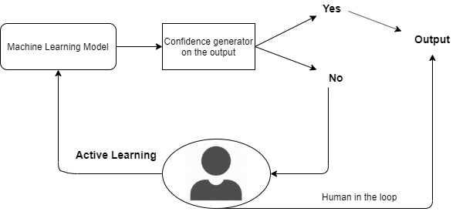

*Fig 38: Active Learning Model*

# 

# Bibliography

1. *Amazon Comprehend*. (n.d.). From aws: https://aws.amazon.com/comprehend/

2. Armand Ruiz. (2017). *The 80/20 data science dilemma*. From Infoworld: https://www.infoworld.com/article/3228245/the-80-20-data-science-dilemma.html

*3. aws*. (n.d.). From EMR-pricing: https://aws.amazon.com/emr/pricing/

4. Bansal, S. (2016). *Beginners Guide to Topic Modeling in Python*. From Analytics Vidhya: https://www.analyticsvidhya.com/blog/2016/08/beginners-guide-to-topic-modeling-in-python/

5. Cheah, . K. (2019). *Vegas Baby*. From Medium: https://medium.com/@kencheah/vegas-baby-1213890614eb

*6. Content-based Filtering*. (n.d.). From developers: https://developers.google.com/machine-learning/recommendation/content-based/basics

*7. Daily Active User* . (n.d.). From https://baremetrics.com/academy/daily-active-user

*8. Ec2*. (n.d.). From aws: https://aws.amazon.com/ec2/

*9. Flask-Framework*. (n.d.). From Stackoverflow: https://stackoverflow.com/questions/12547206/flask-framework-mvc-pattern/12547285

10.Goyal, A. (n.d.). *Sentiment Analysis for Movie Reviews*. From 11.https://cseweb.ucsd.edu/classes/wi15/cse255-a/reports/fa15/003.pdf

*12. Gunicorn and Nginx in a Nutshell*. (n.d.). From https://vsupalov.com/gunicorn-and-nginx/

13.Gupta, S. (2019). *Word Embeddings in NLP and its Applications*. From Hackernoon: 14.https://hackernoon.com/word-embeddings-in-nlp-and-its-applications-fab15eaf7430

15. Koehrsen, W. (2018). *Feature Engineering: What Powers Machine Learning*. From https://towardsdatascience.com/feature-engineering-what-powers-machine-learning-93ab191bcc2d

16.Krishni. (2018). *K-Fold Cross Validation*. From Medium: https://medium.com/datadriveninvestor/k-fold-cross-validation-6b8518070833

17.Kusnetzky, D. (2014). *Databricks makes Hadoop and Apache Spark easy to use*. From Zdnet: ) https://www.zdnet.com/article/databricks-makes-hadoop-and-apache-spark-easy-to-use/

*18.lasvegas*. (n.d.). From http: https://www.visitlasvegas.com/

*Machine Learning model*. (n.d.). From Geeksforgeeks: https://www.geeksforgeeks.org/saving-a-machine-learning-model/

*19. Management guide*. (n.d.). From aws: https://docs.aws.amazon.com/emr/latest/ManagementGuide/emr-overview.html

20. Nguyen, T. (2017). *Introduction to Recommendation Systems*. From Slideshare: https://www.slideshare.net/tantrieuf31/introduction-to-recommendation-systems

*21. Parquet*. (n.d.). From Databricks: https://databricks.com/glossary/what-is-parquet

22. Rencberoglu, E. (2019). *Fundamental Techniques of Feature Engineering for Machine Learning*. From Medium: https://towardsdatascience.com/feature-engineering-for-machine-learning-3a5e293a5114

23. Rocca, B. (n.d.). *Introduction to recommender systems* . From Medium: https://towardsdatascience.com/introduction-to-recommender-systems-6c66cf15ada

*24. SDK for python*. (n.d.). From aws: https://aws.amazon.com/sdk-for-python/

25. Shah, T. (2017). *About Train, Validation and Test Sets in Machine Learning*. From Medium: 26. https://towardsdatascience.com/train-validation-and-test-sets-72cb40cba9e7

*27. Spark sql*. (n.d.). From Databricks: https://databricks.com/glossary/what-is-spark-sql

28. Stephenson, B. (2019). *Yelp*. From Lifewire: https://www.lifewire.com/what-is-yelp-4685842

*29. Topic Modeling*. (n.d.). From aws: https://docs.aws.amazon.com/comprehend/latest/dg/topic-modeling.html